Introduction
This induction applies to all contractors and shoreside staff working on RV Tangaroa while it is in port. The purpose of this induction is to help you familiarise yourself with the vessel, understand key H&S requirements, know what to do in an emergency and to ensure you get home safely at the end of each day.
Please read through the following information, watch the induction video and complete the quiz at the end. The induction must be completed by the person intending to work on the vessel. If you have not been on the vessel before, you will be given a brief tour of your work area to ensure you are familiar with emergency evacuation routes, locations of call points and safety equipment etc.
When you arrive at the vessel, each person is required to sign the Visitor Register and record time on and off the vessel. Each person is also required to put their ID in the card holder beside the gangway.
This induction is valid for 12 months.
Training Records
Some work requires a particular training qualification, such as:
- Electrical
- Approved filler
- Working at height
- Confined space entry
- Elevated Work Platform
- Scaffolding above 5m
If you are doing any of the above work or other work that requires certification, please send your NIWA Vessel's contact a copy of your latest training certificate(s). Refresher training must be up to date.

Permit to Work
RV Tangaroa operates a permit to work system on board. The permit system is an important tool to manage risk, which takes into account key information such as:
- The location of the work
- Who else could be impacted
- Who needs to be informed
- The hazards involved in the work, and
- The controls that need to be put in place
Your NIWA Vessel's contact will advise you if you require a permit for the type of work you are doing.
Port Inductions
Whatever port you are working in, you will need to complete a port induction. Inductions usually last 12 months. If you are working on the vessel in Wellington, here is the link to the online CentrePort induction. ID cards can be picked up from the Inwards Goods office at CentrePort.
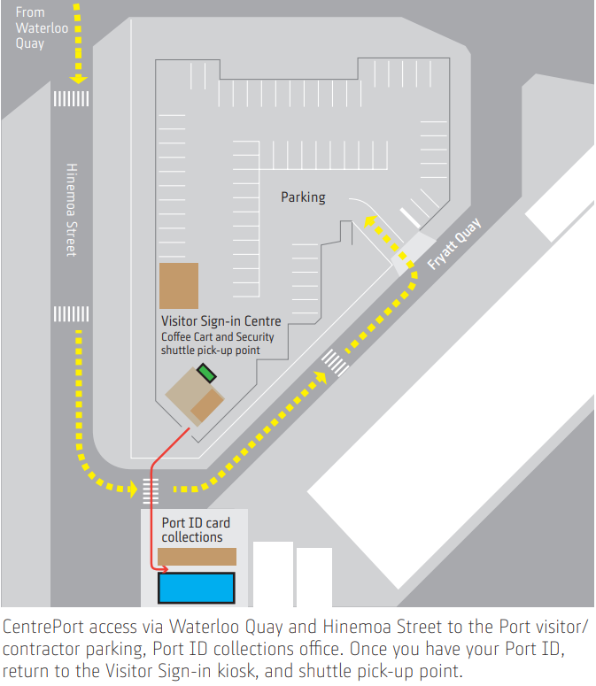
Induction Video and Quiz
Please watch the 10-minute induction video and complete the induction quiz. When you submit your quiz answers, an email will automatically alert the NIWA Vessels office that you have completed the induction.
Click on the links below
Induction video
Induction quiz – Alternatively, if this link does not work, please complete the hard copy quiz below,
and send to ross.mitchell@niwa.co.nz

TANGAROA INDUCTION QUIZ
Personal Name: Date:
Company Name:

1. How do you sign in and off the vessel?
(1 Point)
By putting you name on a whiteboard
By contacting the watchman
By signing the Visitor Register on & off and putting your ID into the card holder and removing it when you leave

2. Upon hearing the ship's alarm, what should you do?
(1 Point)
Immediately leave your work area, go to the muster station and remove your ID from the card holder
Leave the ship immediately
Wait for further instructions

3. Where is the muster station?
(1 Point)
On the wharf
At the top of the gangway
On the bridge
On the back deck

4.What is the minimum PPE required on deck?
(1 Point)
Safety glasses
Safety glasses, Safety boots
Safety glasses, Safety boots, Hi-viz vest
Safety glasses, Safety boots, Hi-viz vest, Hard hat

5. Where is the internal emergency exit shaft?
(1 Point)
Forward on the ship
Aft on the ship

6. Who do you report hazards and incidents to?
(1 Point)
A ship's officer
Anyone
NIWA office

7. Where is the defibrillator located?
(1 Point)
On the bridge
In the mess
In the engine room

8. Where is the fire safety plan located?
(1 Point)
On the bridge
In the mess
On every deck

9. Before and after locking out or tagging any equipment, who do you notify?
(1 Point)
The Chief Engineer
The Master
The Cook

10. If you see an activity that looks dangerous or you feel unsafe yourself, what should you do?
(1 Point)
Stop the job
Ignore it and carry on
Report it at the end of the day

11. Acknowledgement
I acknowledge that I have viewed the induction video, I agree to follow all safety instructions provided to me in this induction and I will follow all other reasonable instructions and relevant safety procedures during the course of my work.
Yes

Scan and send the completed quiz with any relevant training records to the Health and Safety Operations Manager who will update the Contractor Induction Register.

